ARM Limited

CS262- Design Document



Project Supervisor

Mr. Samyan Qayyum Wahla

Project Members(G-5)

|  |  |
| --- | --- |
| Mukaram Ali | 2021-CS-58 |
| Rayan Rasheed  Ammad Aslam | 2021-CS-59  2021-CS-67 |

Department of Computer Science

University of Engineering and Technology, Lahore

Pakistan

Table of Contents

Project Description: 3

Project Features: 4

Technology Stack: 4

Project Actors: 4

Use Cases: 4

Use Case 1: Reset Password 4

Use Case 2: Add Employee 4

Use Case 3: Deduct Fuel Money 4

Use Case 4: Give Salaries 5

Use Case 5: Give Bonus 5

Use Case 6: Update Employee 6

Use Case 7: Add Vehicle 7

Use Case 8: Delete Employee 7

Use Case 9: Buy Stock 7

Use Case 10: Update Stock 8

Use Case 11: Inventory Report 8

Use Case 12: Report Cost 9

Use Case 13: Take Order 9

Use Case 14: Add Client 10

Use Case 15: Cancel Order 10

Use Case 16: To Do list 11

Use Case 17: Assign Location 11

Use Case 18: Track Order 11

Use Case 19: Add Fuel Details 12

Use Case 20: Reset Password 12

User Interface Details 13

Classes: 25

Object Oriented Features: 25

Composition: 25

Inheritance: 26

Multiple Inheritance: 27

Multi-Level Inheritance: 28

Polymorphism: 29

Detailed Object Oriented Design: 30

Data Structure: 31

Exceptions: 33

Data Storage: 34

Email Sending: 34

Project Plan 36

Analytical Reports 37

# Project Description:

We are facing not just a challenging business environment but a rapidly changing one. There is always room for improvement. Running a Distribution System without a proper application can lead to many problems. In the warehouse, by not managing your stock count, cost price changes and not being able to view your stock position can have drastic consequences. The company has no way of knowing how much stock is left in your warehouses and how much you’ve sold out. If you don’t know how much you have left, you can’t restock your inventory which will cause delays and frustrate your customers. It is important to track your inventory so that you can plan ahead effectively. The company is unable to keep a record of its employees, day-to-day sales and profits, customer information and transportation cost. Searching a 10-year-old record for the company is extremely challenging. Speed is also critical when ensuring that you get the correct items picked, packed and distributed to the correct address and client. Understanding the right approach to solving these challenges is essential for distributors to adapt, transform and differentiate themselves in this new challenging business landscape.

We are all aware that we live in an increasing electronic world. Simply put if the Distribution Company is not using a proper, well-managed application then it is facing commercial suicide. So, our Project aims to develop such an application for the Company that can address all the above problems and help the company improve the distribution system and management of the company processes.

The administrator of the application is the General Manager of the company. He can hire the company employees (sales agent), riders (to deliver the packages) and an inventory Manager. He is in the charge of each module. Each employee would have their individual accounts. The inventory Manager is in charge of the warehouse, keeping the record of the product as being delivered by the Manufacturing Company. The sales agent will deal with the clients, their orders and assign the delivery task to the riders depending upon the location assigned to them. The rider would be a given a specific area in which he would have to deliver all the goods and complete all its orders in the given time. Further bonuses will be given according to the statistic chart at the end of the month.

The Distribution Company that we have plumped for is the Shoe Distribution Company. A well-recognized shoe Manufacturing Company **ADIDAS** is our manufacturer. The implementation of this application will work with a company called **ARM**. As a distribution company we deliver the products to numerous retailers, wholesalers, concept stores, buyers and agents all over the Lahore. It operates on its own as it is an independent company establishing a connection between the products and the client.

The Record and performance are also evaluated automatically in order to provide the appraisal. The company established the excellent track record for the best customer satisfaction. As a footwear sourcing company, we also provide sustainable material sourcing options to help our clients choose a greener path. An organization’s main focus must be to satisfy its customers and in order to do so we are providing a refund policy for the client and email verification after the order had been sent to them. Sometimes, the rider doesn’t deliver the parcel to the exact location. So, to overcome this problem we provide the rider with the exact location of client on Google map. The client should place the minimum required order then the sales agent would request the inventory manager for the confirmation of the stock. The application also maintains the daily attendance of the employees, the scheduling of the riders and fuel consumption cost. The clients would also be informed of the special offers. Our system is cited as the most efficient tool that is at the company’s disposal.

The application offers three modes.

* Manager authorized mode.
* Sales Agent authorized mode.
* Inventory Supervisor mode
* Rider authorized mode.

# Project Features:

* User interface screen will be operated according to the role of the person who signs in.
* Client can pay in installments or pay in advance.
* Rider will be informed with the stock availability during placing orders. If the required order of the client is out of stock, order could not be placed and an email would be sent to the Inventory Supervisor to inform about stock unavailability.
* Sales Agent will assign the location of decided area to the Rider. The order will be delivered the very next day.
* Rider could only deliver limited number of orders in a single day.
* Attendance of all employees.

# Technology Stack:

|  |  |
| --- | --- |
| Language | 1. Python |
| IDEs | 1. Visual Studio Community 2. Visual Studio Code |

# Project Actors:

|  |  |
| --- | --- |
| Actor Name | **Manager** |
| Actor Type | Primary |
| Description | Manager can hire and fire employees to the Company. He can view all the records or monthly reports and stock. He also has to check the performances at all times, check inventory. He gives monthly incentives to all the employees according to their performance. |

|  |  |
| --- | --- |
| Actor Name | **Inventory Supervisor** |
| Actor Type | Primary |
| Description | This system will also have an inventory supervisor. He will manage inventory in the warehouse and will notify the general manager whenever a new order should be made. He can buy stock from the supplier after the approval of the General Manager. He will provide authorization to the rider after checking the stock from the warehouse. |

|  |  |
| --- | --- |
| Actor Name | **Sales Agent** |
| Actor Type | Primary |
| Description | Sales Agent will also have an account of its own. He will keep a track of all the orders of the riders and their information. He will assign a specific area to a specific rider. He can also update the location of riders. He will send out email to the client after the delivery of the product. |

|  |  |
| --- | --- |
| Actor Name | **Rider** |
| Actor Type | Primary |
| Description | The Rider has most of the responsibilities in the system. Rider will take order from the shopkeepers and deliver the order afterwards. Rider is able to see the products when creating an  order. He can view the history of his delivered orders and can also view pending orders (to be delivered). He will send out email to sale agent about the order placement. He can add and update the client data. |

|  |  |
| --- | --- |
| Actor Name | **FBR** |
| Actor Type | Off-Stage Actor |
| Description | FBR collect tax from companies from their earned profits under the tax ordinance law, 2001. It is pertinent for all registered companies to pay tax to work legally across country. |

# Use Cases:

**Reset Password:**

|  |  |
| --- | --- |
| Use Case ID | U01 |
| Name | Reset Password |
| Actor | The Manager, Rider, Inventory Supervisor and Sales agent. |
| Description | If the user forgets his/her password, they can reset it. |
| Flow | Base Flow:   1. The user opens the application. 2. He enters the email and password. 3. He clicks on login. 4. A message box appears containing the message “Not matched in Data Base”. 5. He clicks on forget password. 6. After clicking, he receives an email containing the new password.   Repeats step 1-3   1. Successfully login in the main page. |

**Add Employee:**

|  |  |
| --- | --- |
| Use Case ID | U02 |
| Name | Add Employee |
| Actor | The Manager |
| Description | The Manager can add a new employee to the company. It could either be the rider, sales agent, workers or the inventory supervisor. He would take the name, email, CNIC, address, phone number, bank account of the employee. After filling out the details, he will give them a password and status and a base salary depending upon the status. |
| Flow | Base Flow:   1. Customer arrives at company. 2. Fill out the form to give interview. 3. After passing interview, he will officially become company’s employee. To give him access to the application, the manager will register that employ by entering all his details which include his name, CNIC, E-mail address, status, bank account, telephone number. 4. After entering all his information, he has given his login details to login into application.   Alternative Flow:  3a. The employee is a rider.  1. He also assigns a vehicle to the rider. |

**Deduction of Fuel Money:**

|  |  |
| --- | --- |
| Use Case ID | U03 |
| Name | Deduction of Fuel Money |
| Actor | The Manager |
| Description | The rider will send a report to the Manager on a weekly or daily basis about the fuel consumption depending. Depending upon that report money will be deducted from the company account automatically by the confirmation of the Manager. |
| Flow | Base Flow:   1. The rider opens the fuel report. 2. Adds all the information about fuel consumption. 3. After clicking sent report, the Manager will receive the report. 4. The Manager will open finance module and will delete the total amount of money spend on fuel of each vehicle. |

**Give Salaries:**

|  |  |
| --- | --- |
| Use Case ID | U04 |
| Name | Give Salaries |
| Actor | The Manager |
| Description | The Manager is in the charge of giving salaries to all the employees. |
| Flow | Base Flow:   1. The Manager logged into the system. 2. He clicks on the Finance button and from the dropdown menu, he selects “Salaries”. 3. Now he can view the all the employees and the salary that is needed to be paid to them. 4. When the manager clicks pay button, money will be transferred to their account and deducted from the company account. 5. A message box will be shown of successfully transaction of money. 6. An email would be sent out to the employee being paid.   Alternative flow:  1a. The Manager forgets his password.   1. He clicks on ‘Forgot Password’ to recover his account.   4a. Company account does not have enough money to pay the employees.   1. He will debit into the company account. 2. He requests the employee to get paid in installments. |

**Give Bonus:**

|  |  |
| --- | --- |
| Use Case ID | U05 |
| Name | Give Bonus |
| Actor | The Manager |
| Description | The Manager give bonuses to riders and sales agent depending upon their monthly performances based upon bar chart. |
| Flow | Base Flow:   1. The Manager logged into the system. 2. He clicks on the Finance button and from the dropdown menu, he selects “Salaries”. 3. Two bar graphs will be shown to him. First will be of the rider performances based on their total orders and sales agent depending upon the working days. 4. He will select the employee and click on Bonus button. 5. A pop up will be shown in which he will input the bonus amount ranging from 10 thousand to 20 for rider and 5 to 10 thousand for the sales agent. 6. He clicks on pay and the money will be transferred to the employee.   Alternative flow:  1a. The Manager forgets his password.   1. He clicks on ‘Forgot Password’ to recover his account. |

**Update Employee:**

|  |  |
| --- | --- |
| Use Case ID | U06 |
| Name | Update Employee |
| Actor | The Manager |
| Description | The Manager is able to update employees by clicking the button that list the employees and then select the employee whose information needs to be update. |
| Flow | Base Flow:   1. The Manager logged into the system. 2. An employee comes to him and asks to change some information about him. 3. The Manager clicks on the button and gets the list of all the employees of the company. 4. He searches for that particular employee. 5. He clicks and updates the information that is required to be updated.   Alternative Flow:  1a. The Manager forgets his password.  1. He clicks on ‘Forgot Password’ to recover his account  4a. The employee name does not found in the data base.  1. The Manager uses U02. |

**Add Vehicle:**

|  |  |
| --- | --- |
| Use Case ID | U07 |
| Name | Add Vehicle |
| Actor | The Manager |
| Description | The Manager is able to add buy a new vehicle for the riders to deliver the products. |
| Flow | Base Flow:   1. The Manager logged into the system. 2. Today is the day to buy a new vehicle. 3. He clicks on the button of add vehicle. 4. Enters the truck model number and fuel average of that truck. 5. Enters the price of that vehicle. 6. Clicks add. 7. Money gets deducted from the company account.   Alternative Flow:  1a. The Manager forgets his password.  1. He clicks on ‘Forgot Password’ to recover his account. |

**Delete Employee:**

|  |  |
| --- | --- |
| Use Case ID | U08 |
| Name | Delete Employee |
| Actor | The Manager |
| Description | The Manager gets to fire the employee by deleting his information from the Database or when any employee leaves the company. |
| Flow | Base Flow:   1. The Manager logged into the system. 2. An employee comes to him and asks to resign 3. The Manager clicks on delete employee option. 4. The Manager gets the list of all the employees of the company. 5. He searches for that particular employee. 6. He clicks and deletes that employee.   Alternative Flow:  1a. The Manager forgets his password.  1. He clicks on ‘Forgot Password’ to recover his account  5a. The employee is a rider.  1. The vehicle associated with is now free and can be assign to any new rider. |

**Buy Stock:**

|  |  |
| --- | --- |
| Use Case ID | U09 |
| Name | Buy Stock |
| Actor | Inventory Supervisor |
| Description | Inventory Supervisor will be able to buy the products according to its requirement. Before placing the order, he will get confirmation from the manager through the email and we are assuming the products will be reached after one day and check-in by inventory manager. Moreover, manager can also buy stock. |
| Flow | Base Flow:   1. Supervisor will click the Buy stock button in the side bar menu. 2. Buy Stock page will be shown to the supervisor. 3. He can see how much products are available in the stock. 4. He can place the order by filling the information like product name, size, quantity, category, color, and then clicking on the Buy Product button. 5. After this, price of individual product and the price of total placed order will be shown to him. 6. Here the constraint will be applied that he cannot place the order when he buys product less than a certain quantity. 7. The manager will receive the confirmation email from the supervisor. It is upon him whether he confirms the order or he cancels the order. 8. When he receives the confirmation email from the manager then the confirmed order will be placed. 9. The order will be added in the stock after one day.   Alternative Flow:  8a. In case supervisor receives the rejection email from the manager then he cannot place order.  1. The inventory Supervisor will cancel the order. |

**Update Stock:**

|  |  |
| --- | --- |
| Use Case ID | U10 |
| Name | Update Stock |
| Actor | Inventory Supervisor |
| Description | Inventory supervisor will be able to update the stock when the order will be delivered by the rider. He can also view the pending orders and the completed orders. |
| Flow | Base Flow:   1. Supervisor when click on the Update stock button, Update stock screen will be shown to him that contains a table with each row containing the placed and confirmed orders. 2. He can update the stock by clicking on the checkout button when the order will be delivered successfully and automatically these things will be deducted from the warehouse stock. 3. When supplier deliver its order to the warehouse, then supervisor clicks on the checkout button and the stock will be added in the warehouse.   Alternative Flow:  2a. The order has not been delivered yet and the supervisor clicks the checkout button then message box will be shown to him that contains the message that you cannot update the stock now. |

**Inventory Report:**

|  |  |
| --- | --- |
| Use Case ID | U11 |
| Name | Inventory Report |
| Actor | Inventory Supervisor |
| Description | Inventory supervisor will be able to view a table containing the products of all categories and their quantity in the stock. He can also check the history of the placed orders from the suppliers with their bills. |
| Flow | Base Flow:   1. Supervisor when click on the Inventory Report button, dropdown will be shown to him that contains two buttons. 2. First button would be View Stock, when he clicks this button, he will be able to view the products of all the categories with their available quantity in the stock. He can check the performance of each product with respect to their sales record history by clicking the Check Performance button. By clicking this button, the performance graph will be shown to him. 3. Second button would be View History, when he clicks this button, he will be able to view the history of the changes in the stock i.e. when the new order was placed and added in the stock or when the products were taken from the stock to be delivered to the customer/client. |

**Report Cost:**

|  |  |
| --- | --- |
| Use Case ID | U12 |
| Name | Report Cost |
| Actor | Inventory Supervisor |
| Description | Inventory supervisor can report holding, carrying and total costs. He will calculate the selling cost of the product after calculating all the company expenses. |
| Flow | Base Flow:   1. Supervisor when click on the Report Cost button, the UI screen containing the inputs will be shown. 2. He will fill out all the inputs like Product buying cost, Company expenses, Government Tax, Profit percentage, etc. and then click on the calculate button. 3. After clicking the calculate button the selling price of this product will be shown and that product will be delivered to the customer at that price |

**Take Order:**

|  |  |
| --- | --- |
| Use Case ID | U13 |
| Name | Take Order |
| Actor | Rider |
| Description | Rider will reach his assigned location and take order from the Shop Keeper. The information taken by the rider will reach to the sales agent and then sales agent will perform its certain actions. |
| Flow | Base Flow:   1. Rider reaches the Shop Keeper and he presses the Take Order button. 2. Take Order screen will open where he can see all the products available with their prices and then he takes the order details like Product category, name and quantity. 3. After taking the details from shop keeper he presses the place order button. In result of it the information will be delivered to the sales agent. 4. The receipt will be generated on which the total payment will be shown. 5. Customer can pay in advance, cash on delivery or in installments. 6. Constraint will be applied on the rider that he cannot take orders more than the assigned numbers to him.   Alternative Flow:  5a. There are two possibilities  1. If the shopkeeper places the order first time then he has to pay the payment in advance.  2. If he is already an existing customer then he has the option to pay the payment on delivery or in installments. |

**Add Client:**

|  |  |
| --- | --- |
| Use Case ID | U14 |
| Name | Add Client |
| Actor | Rider |
| Description | Rider will reach his assigned location and take details from the Shop Keeper. The information taken by the rider will reach to the sales agent and then sales agent will perform its certain actions. |
| Flow | Base Flow:   1. Rider reaches the Shop Keeper and he presses the Take Order button. 2. Take Order screen will open where he can see all the products available with their prices. 3. He adds the information of the client including the following details:  * Name * CNIC * Email * Address * Number  1. Then client is having been created and rider takes the order.   Alternative Flow:  1a. The rider forgets his password.   1. He clicks on ‘Forgot Password’ to recover his account   3a. The client is already an existing customer of the company.   1. Rider just enters the CNIC and the remaining information is automatically fills out. |

**Cancel Order:**

|  |  |
| --- | --- |
| Use Case ID | U15 |
| Name | Cancel Order |
| Actor | Rider |
| Description | The rider can check the orders created. He has an option to view all the pending orders that have to be delivered in the given amount of time. He can also cancel the order if asked by the customer. |
| Flow | Base Flow:   1. The rider logged in to the system. 2. He clicks the button to check the to-do-list. 3. After clicking, all the order that have not been delivered to the required customers will be shown to him. 4. He is taking order and at that time, opens this window, he will also have an option to delete or cancel the order.   Alternative flow:  1a. The rider forgets his password.   1. He clicks on ‘Forgot Password’ to recover his account.   6a. The shopkeeper wants to cancel half, less than half or more from the order he just placed.   1. When rider clicks on the ‘cancel’ button of that order, he will be displayed the quantity which he can increment or decrement according to the wish of the shopkeeper   6b. The shopkeeper wants to cancel half, less than half or more from the order he placed at the time of delivery.   1. A message box will be shown that the client cannot cancel his order now.   1a. He insists on cancel the order and refuse to receive.  1. When rider clicks on the ‘cancel’ button of that order, 10% will be deducted from the advanced payment of the order.  2. The order is delivered back to the warehouse and gets added in the stock. |

**To Do List:**

|  |  |
| --- | --- |
| Use Case ID | U16 |
| Name | To Do list |
| Actor | Rider |
| Description | The rider can check the orders created. He has an option to view all the pending orders that have to be delivered in the given amount of time. |
| Flow | Base Flow:   1. The rider logged in to the system. 2. He clicks the button to check the to-do-list. 3. After clicking, all the order that have not been delivered to the required customers will be shown to him. 4. He can click on any specific pending order to check its details. 5. Remaining delivery time of all orders is also shown on the right side. 6. He clicks on tick button when the order is delivered and payment is received.   Alternative flow:  1a. The rider forgets his password.   1. He clicks on ‘Forgot Password’ to recover his account. |

**Assign Location:**

|  |  |
| --- | --- |
| Use Case ID | U17 |
| Name | Assign Location |
| Actor | Sales Agent |
| Description | Sales Agent will assign the location to all the riders on weekly basis. |
| Flow | Base Flow:   1. The sales agent logged into the system. 2. He clicks on the assign location button in side bar menu and the screen will be shown to him. 3. He will select the rider from the dropdown. 4. He can then select the location from the drop down and clicks on the assign button. The location will be assigned. 5. He can also view a data grid that show the details of all the riders with their locations assigned   Alternative Flow:  1a. The sales agent forgot its password.   1. The sales agent clicks on “Forgot Password” to recover his account. |

**Track Order:**

|  |  |
| --- | --- |
| Use Case ID | U18 |
| Name | Track Order |
| Actor | Sales Agent |
| Description | Sales Agent has the power to view all the riders current and previous orders history. |
| Flow | Base Flow:   1. The Sales Agent logged into the system. 2. He clicks on the track order button to get the information about an order. 3. He selects the name of the riders from the dropdown menu. 4. The agent gets to view the rider and all his delivered orders and pending orders.   Alternative flow:  1a. The rider forgets his password.   1. He clicks on ‘Forgot Password’ to recover his account. |

**Add Fuel Details:**

|  |  |
| --- | --- |
| Use Case ID | U19 |
| Name | Add Fuel Details |
| Actor | The Rider |
| Description | The rider is also assigned a vehicle by the Manager. The rider adds the Refueling date in the report of fuel consumption. The cost of each day and number of kilometers the vehicle is driven are also added into the report. |
| Flow | Base Flow:   1. The First thing Rider does in the morning is arriving at the gas station. 2. He asks the pump employee to fill the gas. 3. He logged into the system. 4. He clicks on the fuel report 5. He adds truck number at the top only for one time and fuel cost per liter. 6. He adds the date, kilometer being shown on the vehicle’s odometer, total volume of fuel in liters and the cost. 7. He clicks on update and the report is send to the Manager.   Alternative flow:  3a. The Rider forgets his password.   1. He clicks on ‘Forgot Password’ to recover his account. |
|  |  |

**Find Path:**

|  |  |
| --- | --- |
| Use Case ID | U19 |
| Name | Find path |
| Actor | Sales Agent |
| Description | The rider is also assigned a vehicle by the Manager. The sales agent will assign him a field area. To deliver orders, rider have to use minimum fuel. So, sales Agent will define a shortest path to deliver orders to minimize fuel cost and maximize profit. Sales agent will use google maps to show him shortest path. |
| Flow | Base Flow:   1. Sales agent will open his portal by entering user name and password. 2. He will open the tab to define areas of sales agent. 3. After assigning areas he will open maps and make shortest path from map and provide it to riders to minimize fuel cost. 4. After the rider got order. At the next day he will automate shortest path to deliver that number of orders. 5. So, riders will deliver those orders in time.   Alternative flow:  1a. The sales agent forgets his portal password.   1. He clicks on ‘Forgot Password’ to recover his account.   3a. If rider found traffic on the route, then he will can use any other path but he has  To inform sales agent about that. If the map is providing longer route, he will complain that to sales agent and use his own path.  4a. If rider does not get any order, then sales agent would not make any new path. |

# Use Interfaces:

|  |  |
| --- | --- |
| Interface ID | I01 |
| Name | Add Employee |
| UI Screen (Justin Mind) |  |
| Validators | * Name: Name should be entered in string. * Phone Number: It would be of string type with minimum 11 words. * Age: It would be of int type ranges from 0 to 120 * Bank Account: It should be input of integers with atleast 15 numbers. * CNIC: CNIC will be of string type with 13 characters. * Category: Manager can either select Rider, Supervisor, Sales agent. * Email: Email will be validated with @gmail.com and it is of string type. * Salary: It is of int type. * ID: It is of string type. * Password: It is of string type. |

|  |  |
| --- | --- |
| Interface ID | I02 |
| Name | Update Employee |
| Linked Use Case | U06 |
| UI Screen (Justin Mind) |  |
| Validators | * Name: Name should be entered in string. * Phone Number: It would be of string type with minimum 11 words. * Age: It would be of int type ranges from 0 to 120 * Bank Account: It should be input of integers with at least 15 numbers. It is of string type * CNIC: CNIC will be of string type with 13 characters. * Category: Manager can either select Rider, Supervisor, Sales agent. * Email: Email will be validated with @gmail.com and it is of string type. * Salary: It is of int type. * ID: It is of string type. * Password: It is of string type. |

|  |  |
| --- | --- |
| Interface ID | I03 |
| Name | Give Salary and Bonus |
| Linked Use Case | U04, U05 |
| UI Screen (Justin Mind) |  |
| Validators | * Searching: Searching will be according to the name of the employee. * Bonus: It is of int type. * Checkbox: If the salary is paid then it will be checked otherwise it will be unchecked. |

|  |  |
| --- | --- |
| Interface ID | I04 |
| Name | Company account |
| Linked Use Case | U03 |
| UI Screen (Justin Mind) |  |
| Validators | * Select Category: It is of dropdown menu that contains the value of string type * Company Total: It contain the company total in int. |

|  |  |
| --- | --- |
| Interface ID | I05 |
| Name | Buy Stock |
| Linked Use Case | U09 |
| UI Screen (Justin Mind) |  |
| Validators | * Select Quantity: It is int type * Select Size: It is int type * Price: It is of int type. * Total Amount: It is of int type. |

|  |  |
| --- | --- |
| Interface ID | I05 |
| Name | Update Stock |
| Linked Use Case | U10 |
| UI Screen (Justin Mind) |  |
| Validators | * Check out button will be working when the order will be delivered. |

|  |  |
| --- | --- |
| Interface ID | I06 |
| Name | Report Costs |
| Linked Use Case | U12 |
| UI Screen (Justin Mind) |  |
| Validators | * Name is of string type. * Price is of int type * Taxes are of float type. * Profit margin is also of float type. * Selling price is also of float type. |

|  |  |
| --- | --- |
| Interface ID | I07 |
| Name | View History |
| Linked Use Case |  |
| UI Screen (Justin Mind) |  |
| Validators |  |

|  |  |
| --- | --- |
| Interface ID | I07 |
| Name | View Stock |
| Linked Use Case |  |
| UI Screen (Justin Mind) |  |
| Validators |  |

# User Interface Details

In this section, fill the table for summary that which use case will have the required component. Inside each box, write the counts for each component. If component is not used, write zero.

|  |  |  |  |  |  |  |  |  |  |  |  |  |
| --- | --- | --- | --- | --- | --- | --- | --- | --- | --- | --- | --- | --- |
| Interface Id | TextBox | DropDown | Password Box | Table | Date Field | Buttons | AutoComplete | Radio Button | CheckBox | Menu | Text Area | ProgressBar |
| I01 | 0 | 0 | 0 | 0 | 0 | 0 | 0 | 0 | 0 | 0 | 0 | 0 |
| I02 |  |  |  |  |  |  |  |  |  |  |  |  |

# Classes:

|  |  |  |  |  |
| --- | --- | --- | --- | --- |
| **Class Name** | **Software/ Domain** | **Is Abstract (Yes/No)** | **Is Singleton (Yes/No)** | **Is the class will have parametrized constructor (Yes/No)** |
| Manager |  | No | No | Yes |
| SalesAgent |  | No | No | Yes |
| InventorySupervisor |  | No | No | Yes |
| Rider |  | No | No | Yes |
| User |  | No | No | Yes |
| Employee |  | Yes | No | Yes |
| UserCrud |  | No | Yes | No |
| Client |  | No | No | Yes |
| Account |  | No | No | Yes |
| Path |  | No | No | Yes |
| Attendance |  | No | No | Yes |
| AttendanceRecord |  | No | Yes | No |
| Product |  | No | No | Yes |
| Item |  | No | No | Yes |
| Order |  | No | No | Yes |
| OrderLine |  | No | Yes | No |
| ProductCRUD |  | No | Yes | No |
| Bill |  | No | No | Yes |

# Object Oriented Features:

## Composition:

Example 1: Composition between Product and shoe.

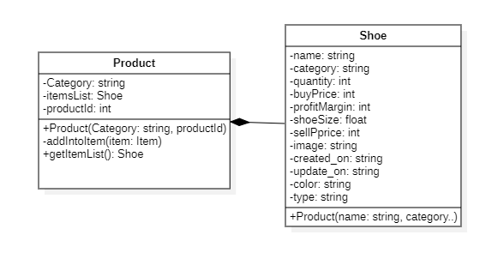

Example 2: Composition between Product and shoe.

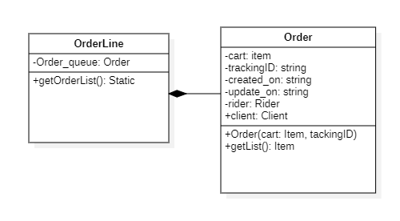

## Inheritance:

Example 1: Extending the User class from Manager and Employee.

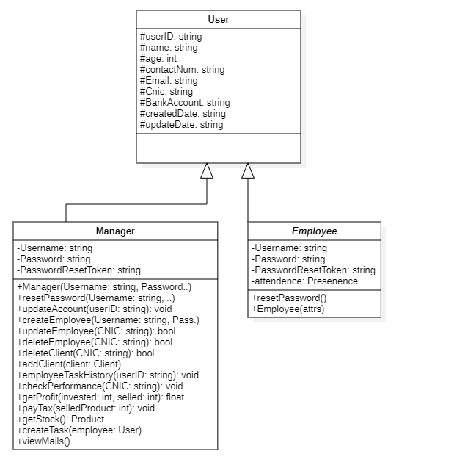

Example 2: Extending the employee from inventory supervisor, driver and sales agent.

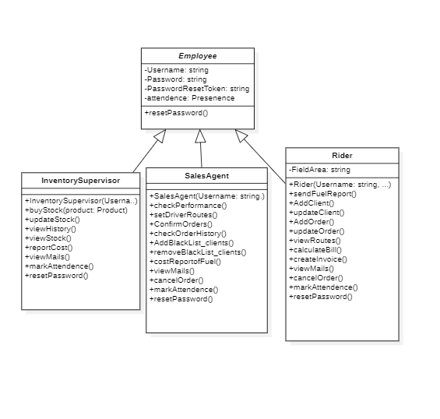

## 

## Multi-Level Inheritance:

Example: Extending the User class from Employee and Employee from Inventory Supervisor, Sales Agent, and Rider class.

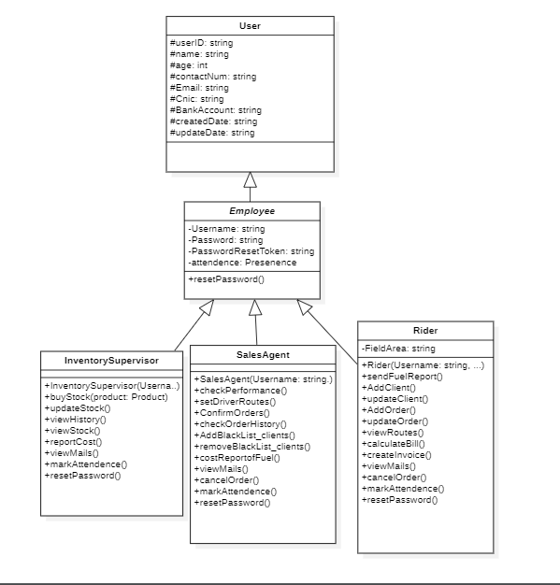

## 

## Multiple Inheritance:

Example: Employee and I Pathfinder are extended the Rider class.

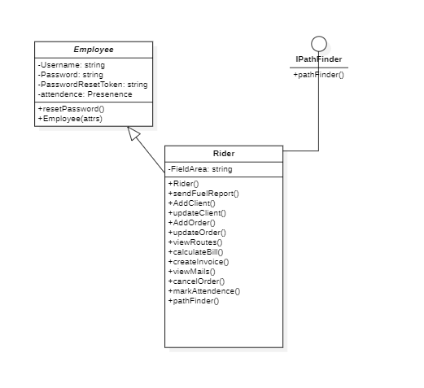

## Polymorphism:

Example: Inventory Supervisor, Rider, and Sales Agent share common properties using abstract function in super class and defining it in sub-classes.

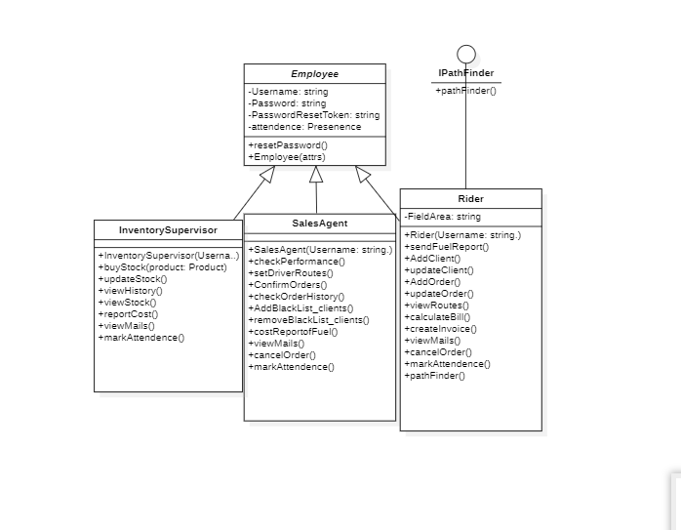

.

# Detailed Object-Oriented Design:

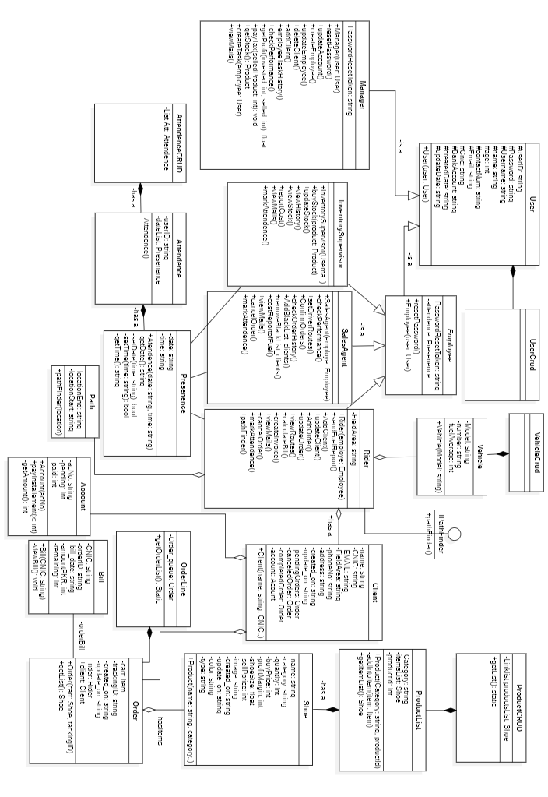

# Data Structure:

|  |  |  |
| --- | --- | --- |
| Use Case Id | Data Structures Used | Justification for the usage of data structure |
| U01 | LinkedList, Hashing table | As user objects are stored in Link list. Because manager do not know exact number of users. Following are justification for using link list:   1. Insertion and deletion in easier than contiguous array. 2. For storing large record, moving pointer in link list is easier than moving object itself. 3. No memory wastage using link list. 4. Time complexity for insert and delete using hash table is **,** and search in hash table also table |
| U02 | LinkedList | As user objects are stored in Link list. Because manager do not know exact number of users. Following are justification for using link list:   1. Link list is dynamic data structure there will be no memory overflow. 2. Insertion and deletion in easier than contiguous array. 3. For storing large record, moving pointer in link list is easier than moving object itself. 4. No memory wastage using link list. |
| U03 |  |  |
| U04 | Stack (using LinkedList) | Manager give salary to employees from company account. So, the employee who has given salary at last is showing in the top. As stack works on LIFO operation so salaries history is storing in stack using link list.   1. As stack using link list will shrink or grow as manager as needed. 2. Their will be no memory usage as stack using link list grows as needed. 3. No memory usage as it shrinks as needed. |
| U05 | BST | Binary Search tree (AVL) tree will be used to keep track of employee having maximum attendance. Whereas, the rider also gets bonuses depending upon their number of completed orders and this record will be save in BST. Justification for using BST is because:   1. In order traversal of BST would give sorted data in time. 2. It will reduce the time complexity for choosing the employee having maximum order from which is case of using array to  time. |
| U06 | LinkedList | As user objects are stored in Link list. Because manager do not know exact number of users. Following are justification for using link list:   1. Link list is dynamic data structure there will be no memory overflow when number of employees are increasing. 2. Insertion and deletion in easier than contiguous array. 3. For storing large record, moving pointer in link list is easier than shifting object itself. 4. No memory wastage using link list. |
| U07 | LinkedList (doubly) | Company will keep buying vehicles with the growth in the business and riders. So, vehicles keep on increasing or may be decrease because of some loss. So, we need a dynamic data structure that will keep record of vehicles.   1. Insertion and deletion in easier than contiguous array. 2. It is dynamic data structure. Hence, there will be no usage of memory as there is no need to pre-allocate the memory. 3. Insertion and deletion are efficient as compared to array because it just moves the pointer instead to shifted object itself. 4. As we are using doubly link list so insertion and deletion will be done in |
| U08 | LinkedList | As user objects are stored in Link list. Because manager do not know exact number of users. Following are justification for using link list:   1. Link list is dynamic data structure there will be no memory overflow unless memory completely filled when number of employees are increasing. 2. Insertion and deletion in easier than contiguous array. 3. Deletion is efficient as compared to array because it just moves the pointer instead to shifted object itself. |
| U09 | ArrayList | In buying stock, the user will exactly know how many items he wants to order to so using array is best option as access of specified product is easy from array.   1. Array allocate contiguous memory location so it will provide random access to product. 2. It is good option to store fixed amount of data(orders). 3. As it has fixed size. Hence, no memory overflow will occur. |
| U10 | Hash Table, Doubly LinkedList | As keeping the products and updating it require a fast lookup over the products. Following is use of given data structure:   1. For large amount of data good hash function if used, hash table will take to search, delete and insert in its average case. 2. Doubly link list is using because insertion in doubly link list take as it has next and back both pointers. 3. Hash table store products in form of key value pair which will offer fast look up at large number of products. |
| U12 | Hash Table, Doubly LinkedList, Stack | View report uses various data structure.   1. Hash table for fast look up of products in company’s warehouse using key value pair in  **.** 2. Stack which store sell products in LIFO. The product that was sell recently will be on top. |
| U13 | LinkedList | We have to store ordered that has been completed. So, we will store in LinkedList.   1. Link list is dynamic data structure there will be no memory overflow unless memory completely filled when number of orders are increasing. 2. Insertion and deletion in easier than contiguous array. 3. Deletion is efficient as compared to array because it just moves the pointer instead to shifted object itself in . |
| U14 | Doubly LinkedList | New added client will be stored in doubly LinkedList.   1. Insertion and deletion in easier than contiguous array. 2. For storing large record, moving pointer in link list is easier than moving object itself. 3. No memory wastage using link list. 4. In doubly LinkedList the insertion and deletion will be in **.** |
| U15 | Queue | As order to do from client is stored in queue to perform FIFO operation on it. So, it will use that stack to delete order  from queue.   1. Using queue, we can process items in order. 2. Using queue, number of orders can be managed   Ease. |
| U16 | Queue using ArrayList | Order to do from client is stored in queue to perform FIFO operation on it. The ordered taken first will be delivered first.  from queue.   1. Using queue, we can process items in order. 2. As rider have to manage multiple orders from client so queue will be useful to manage order in order. 3. Using queue, number of orders can be managed. |
| U17 | string | Rider will assign field region. To store that field area, we will use string. |
| U18 | stack | Sales agent will inform the latest status about that order from inventory manager, and rider.   1. Stack use LIFO operation. So, the sales agent will know the latest status of order. 2. Stack will maintain the order process by displaying latest status at top. |
| U19 | BST | To store fuel details of a month or week. We will use BST.   1. We will get fuel report according to date by In order walk. 2. Time complexity for searching in accordance with date is |
| U20 | Graph | Graph can be used to represent paths.   1. **Dijkstra Algorithm** will be used to calculate shortest path between two locations. 2. Graph will represent the direction of path that rider will follow. |

# Exceptions:

|  |  |  |  |
| --- | --- | --- | --- |
| Type of Exception | Why this exception will occur | Use Case Id in which exception could be occurred | How you will handle the exception |
| Login exception | Due to the user forgets his/her login password. | All Use Case Id’s | Click on option of ‘Forget your password’. An email will be sent to the user containing the new password. |
| Update  Stock exception | If the inventory Supervisor tries to deceive the company. | U03 | The inventory manager can press on checkout button of that order after a day (meaning the order has been delivered in the warehouse). Otherwise, a message box will be shown. |
| Stock Unavailability exception | If the required product by the client is not available in the warehouse. | U06 | An email would be sent out to the inventory Supervisor to buy the required product. If the Supervisor buys it from the supplier, then it will be shown to the rider in the available product list. |
| Cancel-Order  exception | If the user clicks on delete order button asked by the client when the delivery of that order is on the way. | U07 | He would be shown a message box containing that the client cannot change or delete his order now. |
| Cancel-Order  exception | If the client does not receive the delivery. | U07 | The company will refund 90% of the advance payment of the order. |
| Insufficient-Balance exception | When the manager is paying salaries to the employees and the company account runs out of cash. | U10 | The manager pays the employee in installments or after some days when orders get delivered and company gets cash. |
| Client-Email exception | When the rider is taking the information of client during placing his order and the client tells he does not have an email account. | U13 | The email would be optional and all the report of the client will be dealt keeping the CNIC in consideration. |

# Email Sending:

We are sending emails to different users on different occasions. All of them are listed below:

1. The Manager receives an email from the inventory Supervisor regarding the purchasing of the products from the supplier.
2. An email is also sent out by the Sales agent to the client when his order gets delivered.
3. An email is sent out to the user requesting for password update.
4. An email is also sent out when the rider is taking the order from the shopkeeper.
   * 1. If the stock is available then it is sent out to the Sales agent for the confirming the order.
     2. If the stock is not available then to the inventory Supervisor.

* **Email 1:**

|  |
| --- |
| Subject: Products Purchasing  Dear Manager,    Please check your notification for confirmation of the order #001 from ADIDAS New York. The details are given below:  Quantity: 1000 pieces  Size: 8.5  Color: Black  Type: Flip Flops  Price: 2000 per piece  Total amount: 2000000  Kindly, let us know about the status of this order as soon as possible.  Thanks  Regards,  ABC |

* **Email 2:**

|  |
| --- |
| Subject: Order have been Delivered  Dear Customer,  Your Order #2120 from ARM limited have been Delivered today. The order summary is:  Quantity: 1000 pieces  Size: 8.5  Color: Black  Type: Flip Flops  Price: 2200 per piece  Subtotal: PKR 2200000  Taxes: PKR 0  Total: 222210000  **Customer Information:**  Ammad Aslam  Panorama Shop#123  Lahore 55000  Pakistan  Thank you very much for your purchase. We look forward to do further Business with you. |

**Email 3:**

|  |
| --- |
| Subject: Forget Password  Dear User,  Your new password of the account is **puy78992**. Enter this now to have access to your account.  Regards,  ARM limited. |

* **Email 4:**

|  |
| --- |
| Email 4i:  Subject: Order Confirmation  Dear Sales Agent,  There has been a placement of order from **Shop #99 Ali Shoes DHA, Phase I Lahore**. The order details are:  Quantity: 500 pieces  Size: 8  Color: Black  Type: Flip Flops  Price: 2500 per piece  Total: 12500000  Kindly, give permission to place the order. Waiting for reply.  **Rider Information**  Abdullah Ali  0321-7893457  `` Area: **DHA, Phase I Lahore** |

* **Email 4a:**

|  |
| --- |
| Subject: Order Unavailability  Dear Supervisor,  While placing order from **Shop #99 Ali Shoes DHA, Phase I Lahore**, the product was unavailable in the warehouse. The product details were:  Size: 8  Color: White  Type: Sneakers  Present Quantity in Warehouse: 10  Required: 1200    Kindly, give notification of the availability of the stock.  **Rider Information**  Abdullah Ali  0321-7893457  `` Area: **DHA, Phase I Lahore** |

# Project Plan

This section should include the implementation plan and work division among the members. All the estimated dates should be before December 20, 2022 including report and presentation.

|  |  |  |  |
| --- | --- | --- | --- |
| **Use Case Id** | **Use Case Name** | **Member Name** | **Estimated Completion Date** |
| U01 | Reset Password | Rayan | 5 December |
| U02 | Add Employee | Ammad | 4 December |
| U03 | Deduct Fuel Money | Mukaram | 6 December |
| U04 | Give Salaries | Rayan | 9 December |
| U05 | Give Bonus | Ammad | 9 December |
| U06 | Update Employee | Rayan | 5 December |
| U07 | Add Vehicle | Mukaram | 4 December |
| U08 | Delete Employee | Rayan | 6 December |
| U09 | Buy Stock | Ammad | 5 December |
| U10 | Update Stock | Ammad | 6 December |
| U11 | View Inventory Report | Ammad | 8 December |
| U12 | Report Cost | Ammad | 9 December |
| U13 | Take Order | Mukaram | 6 December |
| U14 | Add Client | Ammad | 4 December |
| U15 | Cancel Order | Mukaram | 8 December |
| U16 | To Do list | Mukaram | 9 December |
| U17 | Assign Location | Mukaram | 12 December |
| U18 | Track Order | Rayan | 11 December |
| U19 | Add Fuel Details | Rayan | 13 December |
| U20 | Find Path | Rayan, Ammad | 16 December |

# Analytical Reports

**Customer Relation management report:** CRM analytical report will give us information about the customer who ordered the most expensive products. In addition, graph of the customer who ordered the most products this month.

**Fuel report:** This report provides a table of the fuel information of the vehicle assigned to each rider. Each rider would have its own fuel report.

**Sales and purchase Analytical report:** Analytical report display the analysis of the purchase orders raised against the suppliers daily.

# Analytical Report Format:

